Hack Remote Windows 10 PC using

ARCANUS (Bypass All Antivirus)

ARCANUS is a customized payload generator/handler for penetration testing only

**WHY USE ARCANUS ?**

▪ İn pen.test world Metasploit is the mainstream for this job, but ARCANUS has few advantages.

▪ ARCANUS generates a unique payload for windows and linux systems that can’t be detected with any antivirus programs. (Don’t give any samples to Virus Total or similar web sites to keep it that way ;D )

▪ It has extra modules for exploitation. Ordinary reverse shell payloads offers only remote access to command prompts but ARCANUS has few special commands like ” £persistence, £download,

£upload, £meterpreter…”

▪ It is silent and continuous. Metasploit payloads attempts to connect remote host just for ones but when you execute ARCANUS payloads they makes connection attemps every 5 second silently in background.

▪ It is flexible. If you want to use it with Metasploit it has a meterpreter module for executeing meterpreter shellcodes on remote machine.

▪ Platform independent ! ARCANUS works both on windows and linux.

Open your kali Linux terminal and type the following command

**https://github.com/EgeBalci/ARCANUS.git**

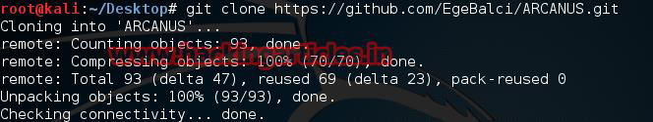

Open terminal and type ./**ARCANUS** and press enter to continue

Now it will ask you for your choice **press 2** now a pop up will open click on **enter**

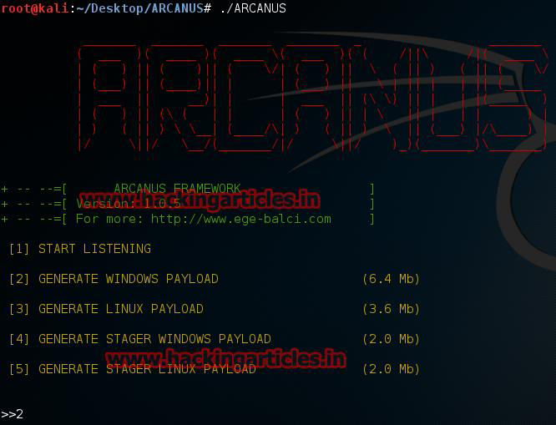

Now Enter IP addresses of your kali Linux pc. And press enter. In next step it will ask for port no. Enter the port no. Such as **4444** and press enter

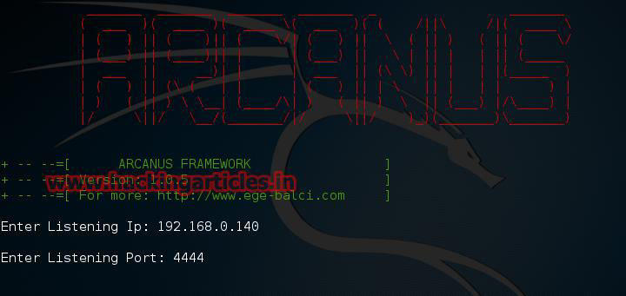

Now it will save a file with name **payload.exe** now send your **exe** files to victim using any social engineering technique.

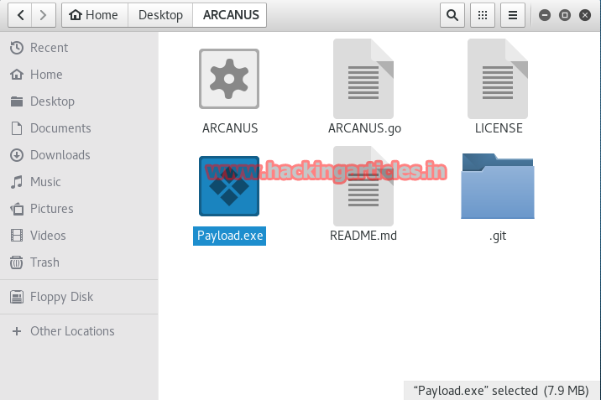

Go to **http**[**s://www.virustotal.com/en**](http://www.virustotal.com/en)

Click the “**Choose File**” button. Navigate to and double-click the **payload.exe.** Appears in the

“Choose File” box, as shown below:

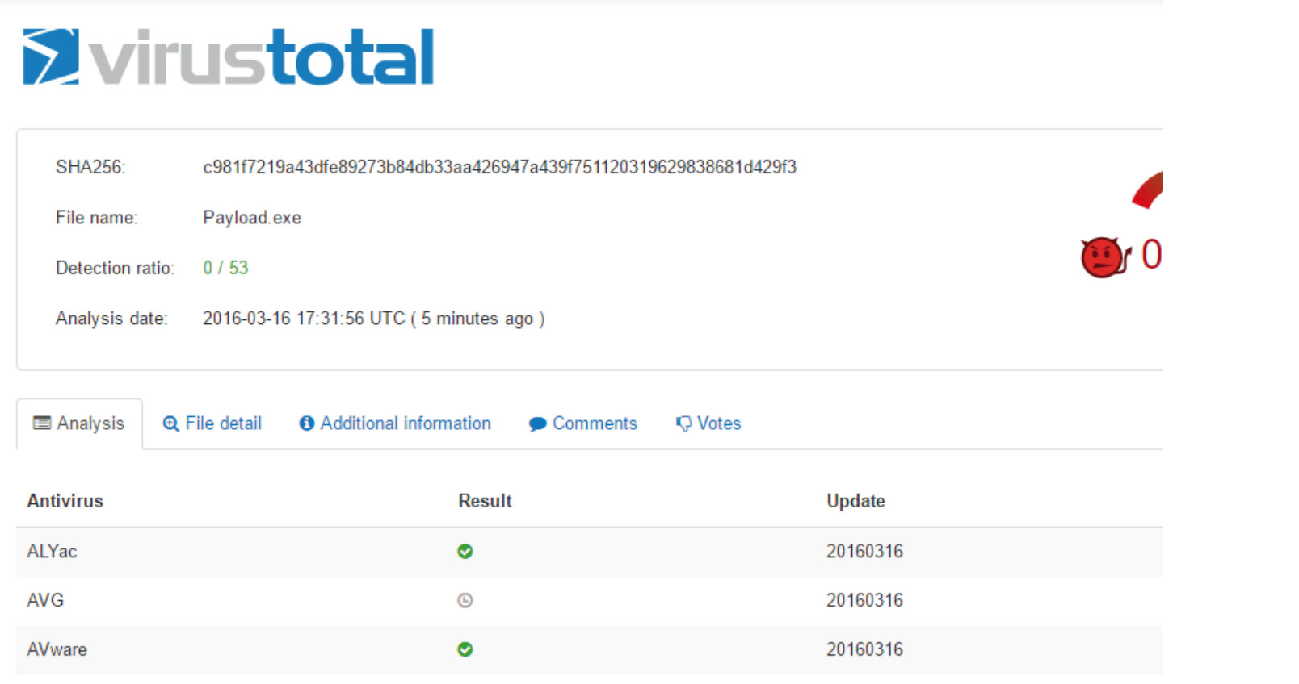

Now when the victim opens **payload.exe** you can access of windows command prompt. Now run **SystemInfo** in prompt, will tell you all you need to know about your computer system

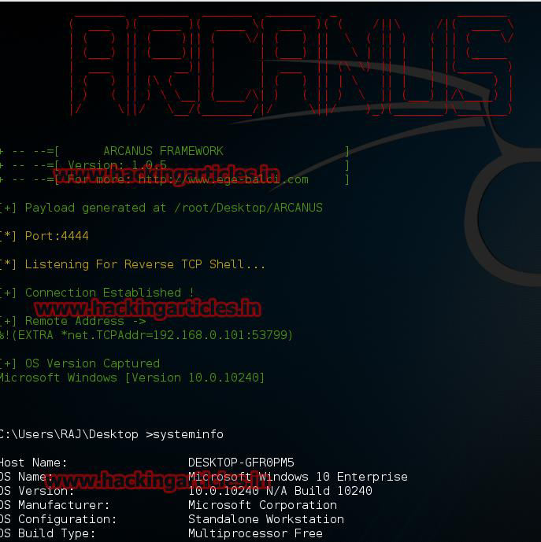

When we need to retrieve a file from the target we use the **download** command

**£download “Filename” /root/Your Path**

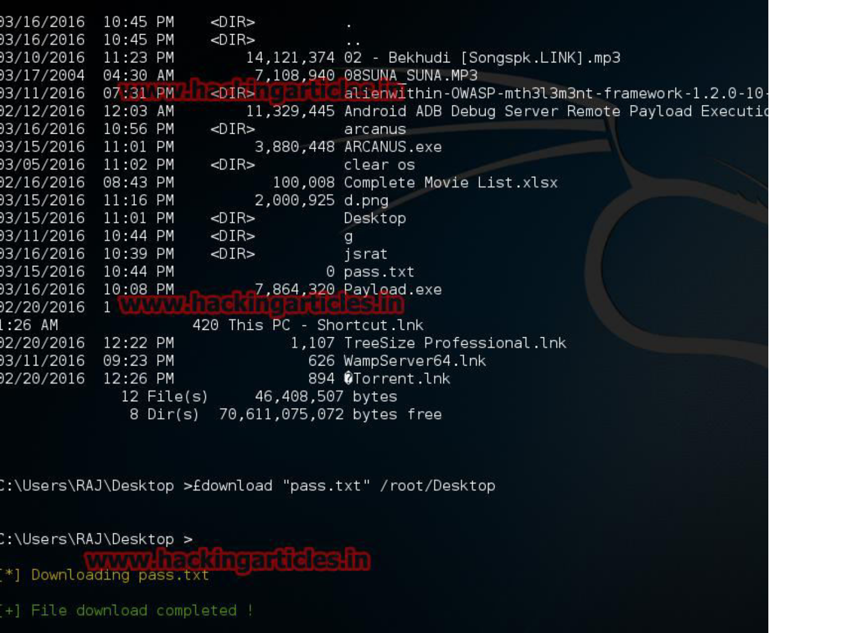

**For More Command visit here**